**Practical : 08**

**AIM:** **Demo of Clustering.**

Theory : K-means Clustering Algo:

K-means is an unsupervised learning method for clustering data points. The algorithm iteratively divides data points into K clusters by minimizing the variance in each cluster.

How does it work?

First, each data point is randomly assigned to one of the K clusters. Then, we compute the centroid

(functionally the center) of each cluster, and reassign each data point to the cluster with the closest centroid. We repeat this process until the cluster assignments for each data point are no longer changing.K-means clustering requires us to select K, the number of clusters we want to group the data into. The elbow method lets us graph the inertia (a distance-based metric) and visualize the point at which it starts decreasing linearly. This point is referred to as the "eblow" and is a good estimate for the best value for K based on our data.

CODE : Create Excel File…

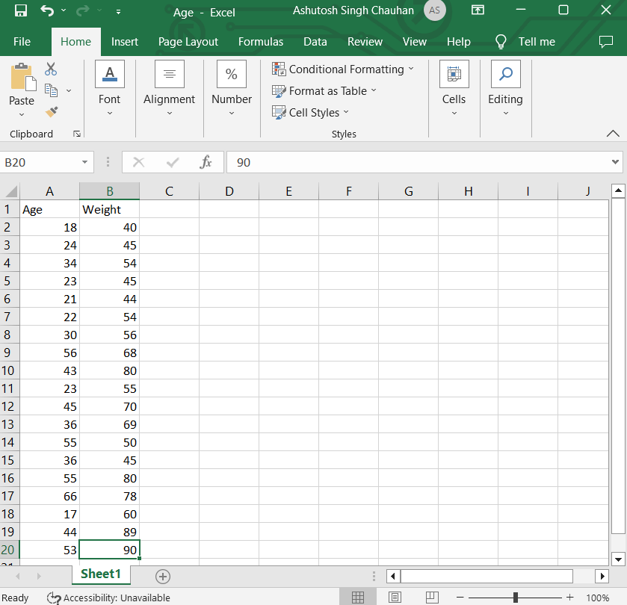

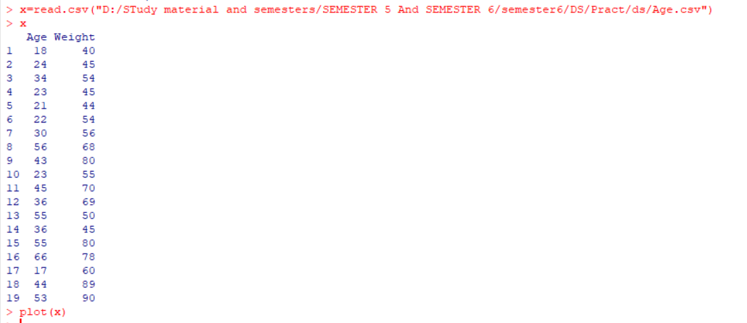

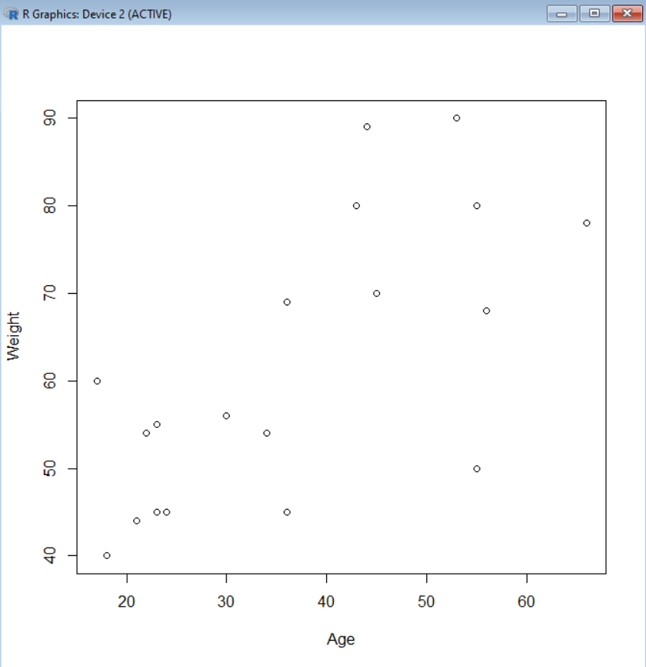



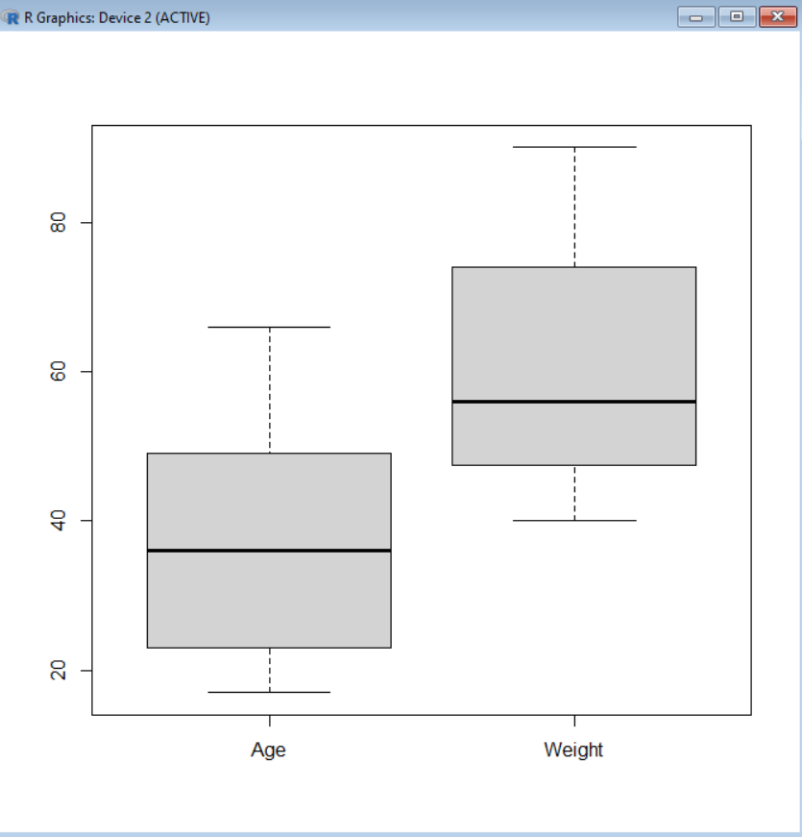

**Make the cluster**

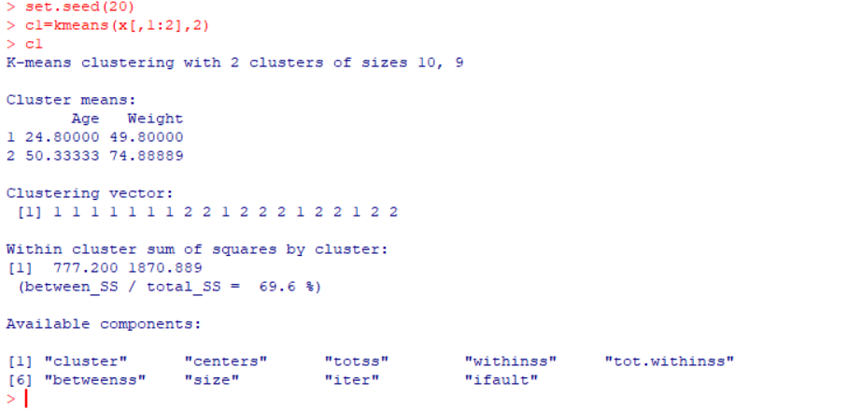

**#SHOW THE IRIS DATA SET**

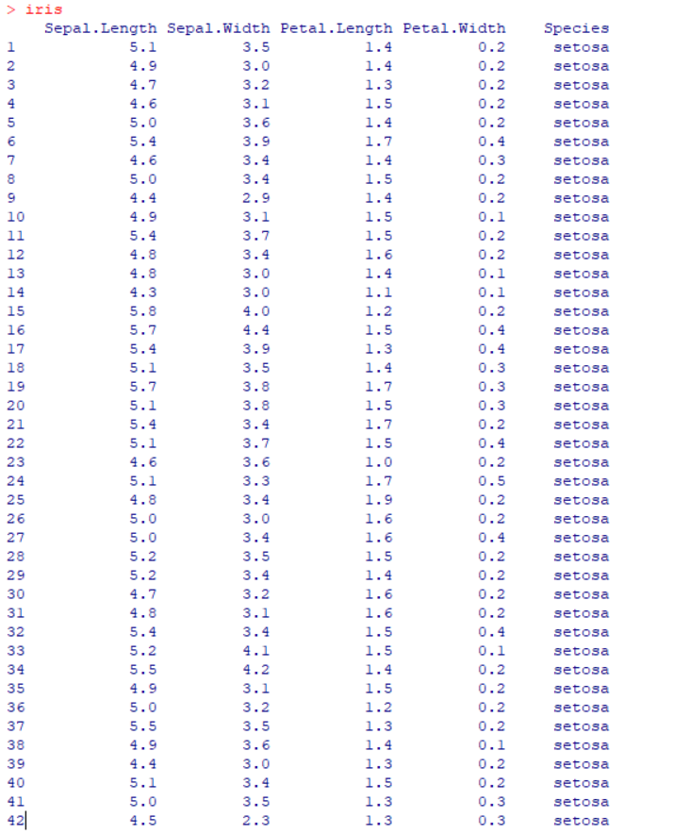



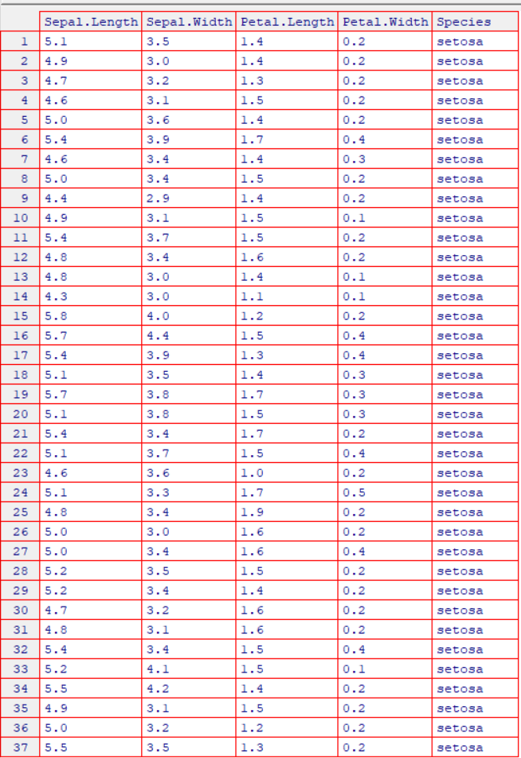

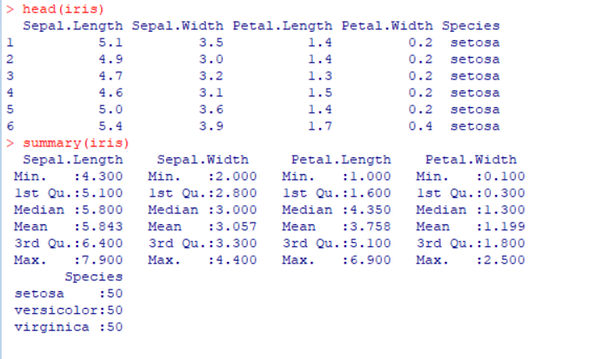

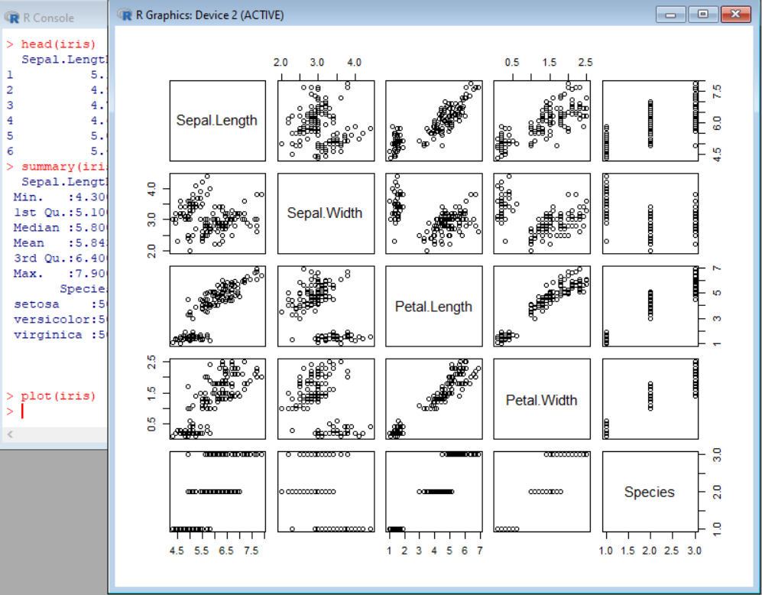

> plot(iris[,3:4])

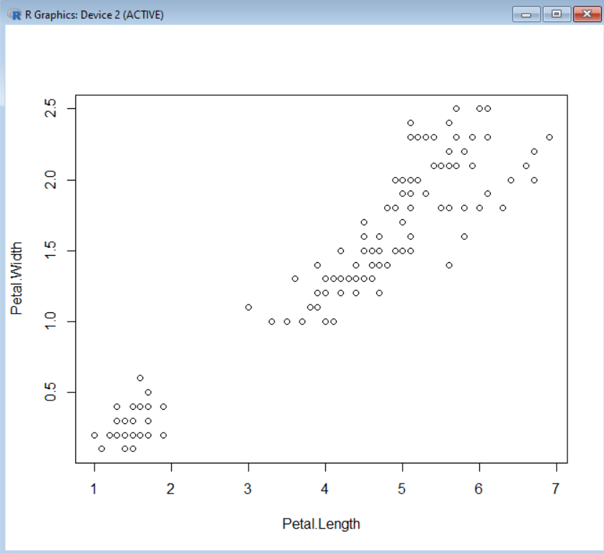

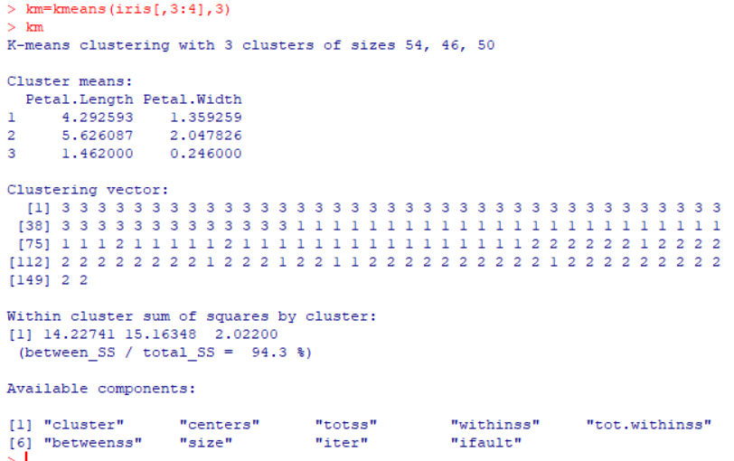

**PRINT CONFUSION MATRIX**

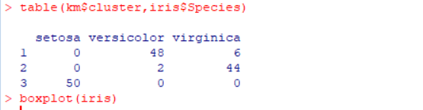

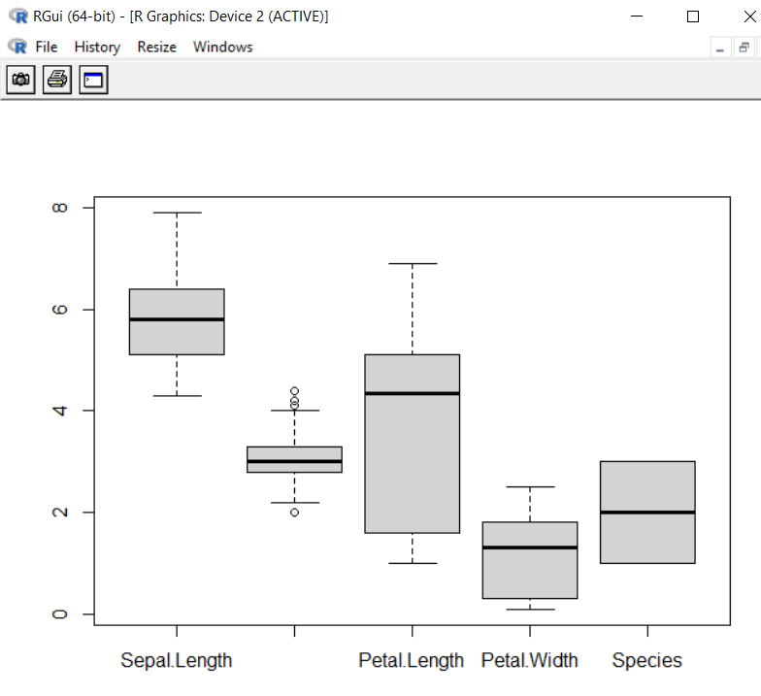

**CONCLUSION:** Thus we have implemented Clustering successfully. Clustering is used to identify groups of similar objects in datasets with two or more variable quantities. In practice, this data may be collected from marketing, biomedical, or geospatial databases, among many other places.